GPIO kernel module for arm linux
I want to build a kernel module that will toggle in a loop a gpio.
Instead doing it using the sysfs.

I would like to start from a Makefile and from the environment to compile and load our module.
The boards are raspberry pi 3 or beaglebone
The compile have the buildroot compiler already installed in output/host/usr/bin
arm-linux-gnueabihf=
The Makefile for arm linux.
obj-m := gpiok.o
KERNELDIR := /home/adsteam/buildroot/BBB/buildroot-2017.05.1/output/build/linux-c17b3de1577dd4e223ee6cc923a1d22b3e1e261b
all:
make ARCH=arm CROSS_COMPILE=arm-linux-gnueabihf- -C $(KERNELDIR) M=$(PWD) modules
clean:
rm -rf *.o *~ core .depend .*.cmd *.ko *.mod.c .tmp_versions

Notes:
The KERNELDIR is from buildroot. So the long hash number is the commit version of the linux kernel.
A X68 Makefile:
obj-m := gpiok.o
all:
make -C /lib/modules/$(shell uname -r)/build M=$(PWD) modules
clean:
make -C /lib/modules/$(shell uname -r)/build M=$(PWD) clean

We will start from simple module to more advanced:
#include <linux/gpio.h>
#include <linux/module.h> // included for all kernel modules
#include <linux/kernel.h> // included for KERN_INFO
#include <linux/init.h> // included for __init and __exit macros

MODULE_LICENSE("GPL");
MODULE_AUTHOR("Eli Arad");
MODULE_DESCRIPTION("Toggle led in raspberry pi 3 using module");
MODULE_VERSION("1.0");

//static char *gpionum = "gpionum";
int gpionum = 0;
module_param(gpionum, int, S_IRUGO); ///< Param desc. charp = char ptr, S_IRUGO can be read/not changed
MODULE_PARM_DESC(gpionum, "The gpio number to toggle"); ///< parameter description

static int __init gpiok_init(void)
{
printk(KERN_INFO "Hello world!\n");
printk(KERN_INFO "gpio num %d\n" , gpionum);
return 0; // Non-zero return means that the module couldn't be loaded.
}

static void __exit gpiok_cleanup(void)
{
printk(KERN_INFO "Cleaning up module.\n");
}

module_init(gpiok_init);
module_exit(gpiok_cleanup);

2.6. Passing Command Line Arguments to a Module
http://www.tldp.org/LDP/lkmpg/2.6/html/x323.html
We can pass parameters to the kernel from type charp( char pointer) to short , int and array.
The initial module contains parameter name gpionum from type int.
To load the module type
Insmod gpiok
Or
Insmod gpiok gpionum=31
Using dmesg we can see the printk:
[1820153.716673] Hello world!
[1820153.716679] gpio num 31

How to load using modprobe.

modprobe check for dependencies in kernel modules and load all the dependencies if exists

To be able to load the module using modprobe:

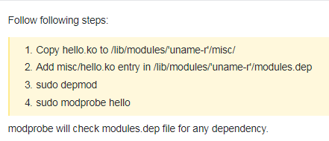

Gpio of raspberry pi 3
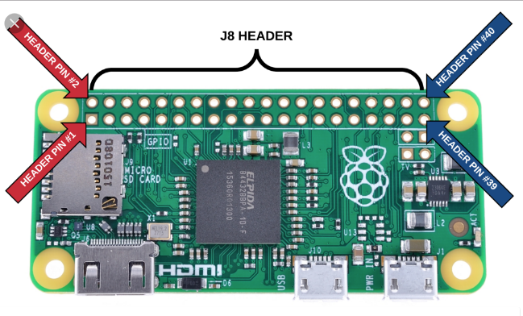

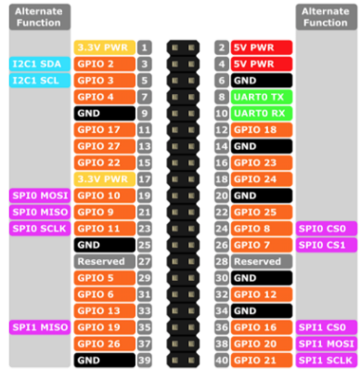

Before we access the gpio, let’s make sure it is connected properly and we can see it using the sysfs gpio.

cd /sys/class/gpio
echo 27 > export

where 27 is the gpio number

echo out > gpio27/direction
echo 1 > gpio27/value

Gpio 27 that we select to toggle is physical pin 13

Let’s write a bash script to toggle the gpio:

while true
do
echo 1 > gpio27/value
sleep 1
echo 0 > gpio27/value
done

And we see the gpio toggle.

Toggle the gpio in our linux kernel module

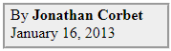
https://lwn.net/Articles/532714/

It is also possible to pass GPIO numbers through platform data or a device tree.

#include <linux/gpio.h>

GPIOs must be allocated before use
int gpio_request(unsigned int gpio, const char *label);

The gpio parameter indicates which GPIO is required, while label associates a string with it that can later appear in sysfs.
A zero return code indicates success

A GPIO can be returned to the system
void gpio_free(unsigned int gpio);

Direction:
int gpio_direction_input(unsigned int gpio);
int gpio_direction_output(unsigned int gpio, int value);

For input GPIOs, the current value can be read with:
int gpio_get_value(unsigned int gpio);

To set value:
void gpio_set_value(unsigned int gpio, int value);

Interrupt:

int gpio_to_irq(unsigned int gpio);

The value for gpio is the return handle from the function gpio_request and not the gpio pin itself.
If interrupt is associated it will return back and then can be hook using
request_irq()

The GPIO subsystem is able to represent GPIO lines via a sysfs hierarchy, allowing user space to query (and possibly modify) them. Kernel code can cause a specific GPIO to appear in sysfs with:
int gpio_export(unsigned int gpio, bool direction_may_change);

The direction_may_change parameter controls whether user space is allowed to change the direction of the GPIO; in many cases, allowing that control would be asking for bad things to happen to the system as a whole. A GPIO can be removed from sysfs with gpio_unexport() or given another name with gpio_export_link().

Our new init function will now be:

static int __init gpiok_init(void)
{
printk(KERN_INFO "Hello world!\n");
printk(KERN_INFO "gpio num %d\n" , gpionum);
if (gpionum != 0)
{
gpio_led = gpio_request(gpionum , "MyLed");
if (gpio_led != 0)
{
printk(KERN_INFO "Gpio allocation failed %d\n" , gpio_led);
}
else
{
printk(KERN_INFO "Gpio allocation ok for %d\n", gpionum);
gpio_direction_output(gpionum, 1);
gpio_export(gpionum, 0);
}
}
return 0; // Non-zero return means that the module couldn't be loaded.
}

The allocation will fail in case it is already exported in sysfs.

Linux kernel Threads

http://tuxthink.blogspot.co.il/2011/02/kernel-thread-creation-1.html

#include <linux/kthread.h> // for threads
#include <linux/time.h> // for using jiffies
#include <linux/timer.h>

variable:
static struct task_struct *thread1;

char our_thread[8]="thread1";

thread1 = kthread_create(thread_fn,NULL,our_thread);
if ( thread1 )
{
wake_up_process(thread1);
}

thread function:
int thread_fn()
{
while (m_moduleAlive == 1)
{
schedule();
}

return 0;
}

stopping threads:

int ret = kthread_stop(thread1);

#include <linux/delay.h>
add 500 ms sleep
msleep(500);

The complete example:
Toggle gpio 27 in raspberry pi 3 ( pin 13)

#include <linux/module.h> // included for all kernel modules
#include <linux/kernel.h> // included for KERN_INFO
#include <linux/init.h> // included for __init and __exit macros
#include <linux/gpio.h>
#include <linux/kthread.h> // for threads
#include <linux/time.h> // for using jiffies
#include <linux/timer.h>
#include <linux/delay.h>

MODULE_LICENSE("GPL");
MODULE_AUTHOR("Eli Arad");
MODULE_DESCRIPTION("Toggle led in raspberry pi 3 using module");
MODULE_VERSION("1.0");

//static char *gpionum = "gpionum";
int gpionum = 27;
module_param(gpionum, int, S_IRUGO); ///< Param desc. charp = char ptr, S_IRUGO can be read/not changed
MODULE_PARM_DESC(gpionum, "The gpio number to toggle"); ///< parameter description
static int gpio_led;

void CreateGpioThread(void);
static int m_moduleAlive = 0;
static struct task_struct *thread1 = NULL;

int threadfunc(void *data)
{
printk ("Thread started..\n");
while (m_moduleAlive == 1)
{
gpio_set_value(gpionum, 0);
schedule();
msleep(500);
gpio_set_value(gpionum, 1);
msleep(500);

}

return 0;
}

void CreateGpioThread()
{
char gpio_thread[]="gpio_thread";
thread1 = kthread_create(threadfunc,NULL,gpio_thread);
if ( thread1 )
{
wake_up_process(thread1);
}
}

static int __init gpiok_init(void)
{

printk(KERN_INFO "Hello world!\n");
printk(KERN_INFO "gpio num %d\n" , gpionum);
if (gpionum != 0)
{
gpio_led = gpio_request(gpionum , "MyLed");
if (gpio_led != 0)
{
printk(KERN_INFO "Gpio allocation failed %d\n" , gpio_led);
}
else
{
printk(KERN_INFO "Gpio allocation ok for %d\n", gpionum);
gpio_direction_output(gpionum, 1);
gpio_export(gpionum, 0);

}

m_moduleAlive = 1;
CreateGpioThread();
}
return 0; // Non-zero return means that the module couldn't be loaded.

}

static void __exit gpiok_cleanup(void)
{
m_moduleAlive = 0;
if (thread1 != NULL)
kthread_stop(thread1);
printk(KERN_INFO "Cleaning up module.\n");
}

module_init(gpiok_init);
module_exit(gpiok_cleanup);

